Problem 1:
Write an 8086 program that prints "START", then unconditionally jumps over a block that prints "SKIPPED". After printing "RESUMED", use JMP to return to the beginning and repeat the sequence exactly 3 times using a manual counter.

Codes:
.model small
.stack 100h
.data
msg_start db 'START$'
msg_skip db 'SKIPPED$'
msg_res db 'RESUMED$'
newline db 13, 10, '$'
counter db 3
.code
main proc
mov ax, @data
mov ds, ax
print_loop:
lea dx, msg_start
mov ah, 09h
int 21h
lea dx, newline
mov ah, 09h
int 21h
jmp skip_block
print_skip:
lea dx, msg_skip
mov ah, 09h
int 21h
skip_block:
lea dx, msg_res
mov ah, 09h
int 21h
lea dx, newline
mov ah, 09h
int 21h
dec byte ptr counter
jz exit_program
jmp print_loop
exit_program:
mov ah, 4Ch
int 21h
main endp
end main
Output:
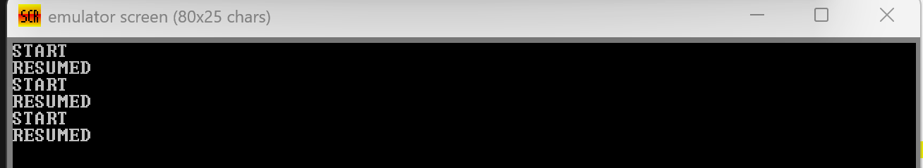
Problem 2:
Write a program that compares two 8-bit values (NUM1 and NUM2). Display "GREATER", "SMALLER", or "EQUAL" depending on the result.

Codes:
.model small
.stack 100h
.data
NUM1 db 45
NUM2 db 30
msg_gt db 'GREATER$'
msg_lt db 'SMALLER$'
msg_eq db 'EQUAL$'
newline db 13, 10, '$'
.code
main proc
mov ax, @data
mov ds, ax
mov al, NUM1
mov bl, NUM2
cmp al, bl
ja print_greater
jb print_smaller
je print_equal
print_greater:
lea dx, msg_gt
jmp display
print_smaller:
lea dx, msg_lt
jmp display
print_equal:
lea dx, msg_eq
display:
mov ah, 09h
int 21h
lea dx, newline
mov ah, 09h
int 21h
mov ah, 4Ch
int 21h
main endp
end main

Output:
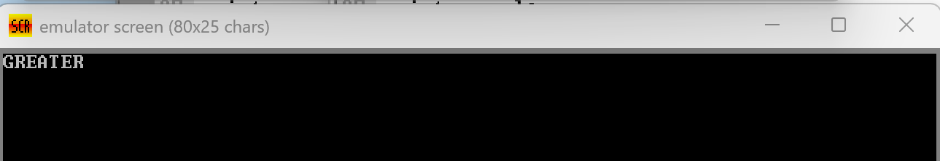

Problem 3:
Write a program that:
- Uses LOOP to print the character '*' 6 times.
- Uses LOOPNZ to scan an array of bytes and stop when a zero is found.
Codes:
.model small
.stack 100h
.data
msg_done db 13, 10, 'SCAN COMPLETE$'
star db '*'
array db 10h, 20h, 00h, 40h, 50h
newline db 13, 10, '$'
.code
main proc
mov ax, @data
mov ds, ax
mov cx, 6
print_star:
mov dl, star
mov ah, 02h
int 21h
loop print_star
lea si, array
mov cx, 5
search_zero:
mov al, [si]
cmp al, 00h
loopnz search_zero
lea dx, msg_done
mov ah, 09h
int 21h
mov ah, 4Ch
int 21h
main endp
end main

Output:
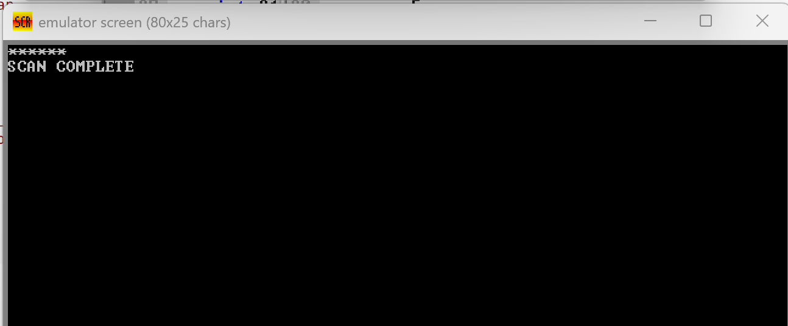
Problem 4:
Write a program that defines a procedure PRINT_TWICE which prints a character passed in DL two times. Call it from main with different characters.

Codes:
.model small
.stack 100h
.data
msg_sep db 13, 10, '---$'
newline db 13, 10, '$'
.code
main proc
mov ax, @data
mov ds, ax
mov dl, 'A'
call print_twice
lea dx, msg_sep
mov ah, 09h
int 21h
mov dl, 'B'
call print_twice
lea dx, newline
mov ah, 09h
int 21h
mov ah, 4Ch
int 21h
main endp
print_twice proc
push ax
push dx
mov ah, 02h
int 21h
int 21h
pop dx
pop ax
ret
print_twice endp
end main

Output:
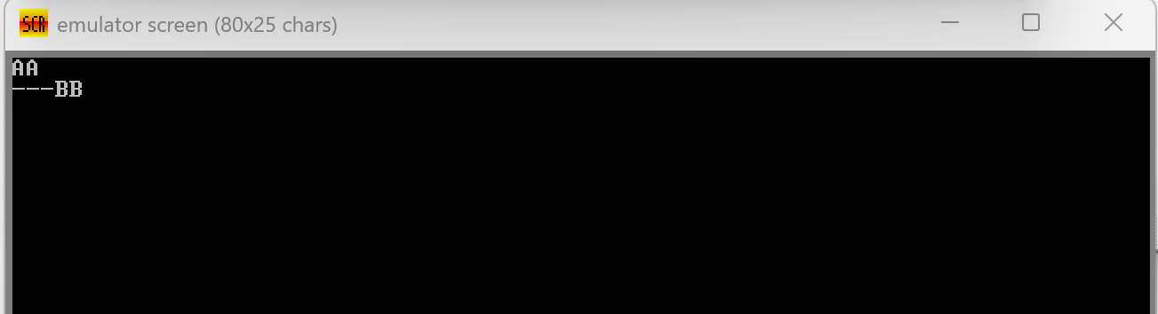
Problem 5:
Demonstrate software interrupts for I/O, interrupt flag manipulation for critical sections, and interrupt return.

Codes:
.model small
.stack 100h
.data
prompt db 'Enter a char: $'
echo_msg db 13, 10, 'You typed: $'
counter db 0
newline db 13, 10, '$'
.code
main proc
mov ax, @data
mov ds, ax
lea dx, prompt
mov ah, 09h
int 21h
mov ah, 01h
int 21h
lea dx, echo_msg
mov ah, 09h
int 21h
mov dl, al
mov ah, 02h
int 21h
cli
inc byte ptr counter
sti
lea dx, newline
mov ah, 09h
int 21h
mov ah, 4Ch
int 21h
main endp
dummy_isr proc far
push ax
push ds
pop ds
pop ax
iret
dummy_isr endp
end main

Output:
